**Project Report**

**on**

**eBook Review System**

By

**Vivek Raut**

Indira College of Commerce and Science, Pune

M.Sc.( Comp.Sci.)

**Project Certificate**

**(should be taken from project guide)**

**TABLE OF CONTENTS**

**CHAPTER 1: INTRODUCTION**

1.1 Existing System and Need for System

1.2 Scope of Work

1.3 Operating Environment – Hardware and Software

**CHAPTER 2: PROPOSED SYSTEM**

2.1 Proposed System

2.2 Objectives of System

2.3 User Requirements

**CHAPTER 3: ANALYSIS & DESIGN**

3.1 Data Flow Diagram (DFD)

3.2 Functional Decomposition Diagram (FDD)

3.3 UML Diagrams

3.3.1 Class Diagram

3.3.2 Object Diagram

3.3.3 Use Case Diagram

3.3.4 Sequence Diagram

3.3.5 Collaboration Diagram

3.3.6 State Diagram

3.3.7 Activity Diagram

3.3.8 Component Diagram

3.3.9 Deployment Diagram

3.4 Entity Relationship Diagram (ERD)

3.5 Data Dictionary

3.6 Table Design

3.7 Code Design

**CHAPTER 4 : USER MANUAL**

4.1 Operations Manual / Menu Explanation

4.2 Menu Screens

4.3 Project code

**CHAPTER 5 : Limitations and Enhancement**

5.1 Drawbacks and Limitations

5.2 Proposed Enhancements

5.3 Conclusions

5.4 Bibliography

**1) INTRODUCTION**

**1.1) Existing System and Need for System**

In Existing System,

* Reviewing books are done by particular book reading community and they review books mostly by conversing between themselves but meeting and conversing about books in large group becomes a tiresome task.
* Giving same review repetitively leads to wastage of energy and time.
* Spoken reviews lacks written record which most of the times leads to misunderstanding about the book. Book read year ago reader may forget the experience he/she felt and after a long time if reader gets asked about book he/she may hesitate to give accurate experience.
* Summing up everyone’s review and making decision about book is challenging.

**System is needed to overcome above problems.**

**1.2) Scope of Work**

For this project, work is divided in teams according to responsibilities as:-

Backend Team.

User Interface Team

Validation Team.

In this, I am a part of Backend Team which is responsible for: -

Storing reviews in database using suitable relational model.

Deciding suitable validating logic at server side and optimizing system.

Writing source code for developed logic.

Linking the backend to frontend and maintaining flow of data from webpage at client side to server side.

**1.3) Operating Environment – Hardware and Software**

**Hardware Requirements: -**

PROCESSOR: - Intel Pentium

RAM: - 2 GB RAM

**Software Requirements: -**

Operating System: - Windows NT/Linux/MacOs

Web Server: - IIS 7

Dot Net Framework: - Dot Net Framework 5.0

Web Browser: - Google Chrome/Firefox

**2) PROPOSED SYSTEM**

**2.1) Proposed System**

In the proposed system, we have following modules.

1. Login Module:-

This module deal with login of existing users and admin by validating username and password

1. Registration Module :-

New user that expect to write reviews must create an account through this module.

1. Book review Module:-If user has registered as reviewer he /she can review a book by searching it ,if it already exists in system else he/she can add new book to system and review it .
2. Book Review History Module: -Here user gets history of all reviews he/she reviewed in past. User can now update past reviews or can delete if it’s not needed.
3. Admin Module :- This module is for admin, in which admin can block reviews which may be inappropriate to other users. Admin can also suspend registered users from system who seem malicious to system by blocking there 3 malicious reviews. Admin can add book if system lacks some books.

**2.2) Objectives of System**

1. Review interface: Review interface provides user to post review about book and henceforth helps him to edit the review if any corrections are needed if user never needs the review after some time, review can be deleted.
2. Admin interface: Admin interface helps system administrator to keep reviews and users in control as advertisements are common in this internet age.
3. Book interface: This interface helps User as well as admin to add new books to system if needed book is not available in system it helps admin to edit books and delete if redundancy is been created. In future this module is going to be completely in admin hands.

**2.3) User Requirements**

eBook review system must have freedom of speech with clean reviews free from advertisements and help a user to get clear knowledge of book.

**Required user interface.**

* Adding reviews
* Editing reviews
* Adding books
* Searching books
* Navigation
* Looking for review history
* Looking for added books history

**3) ANALYSIS & DESIGN**

3.3 UML Diagrams:-

3.3.1 Class Diagram for eBook Review system:-

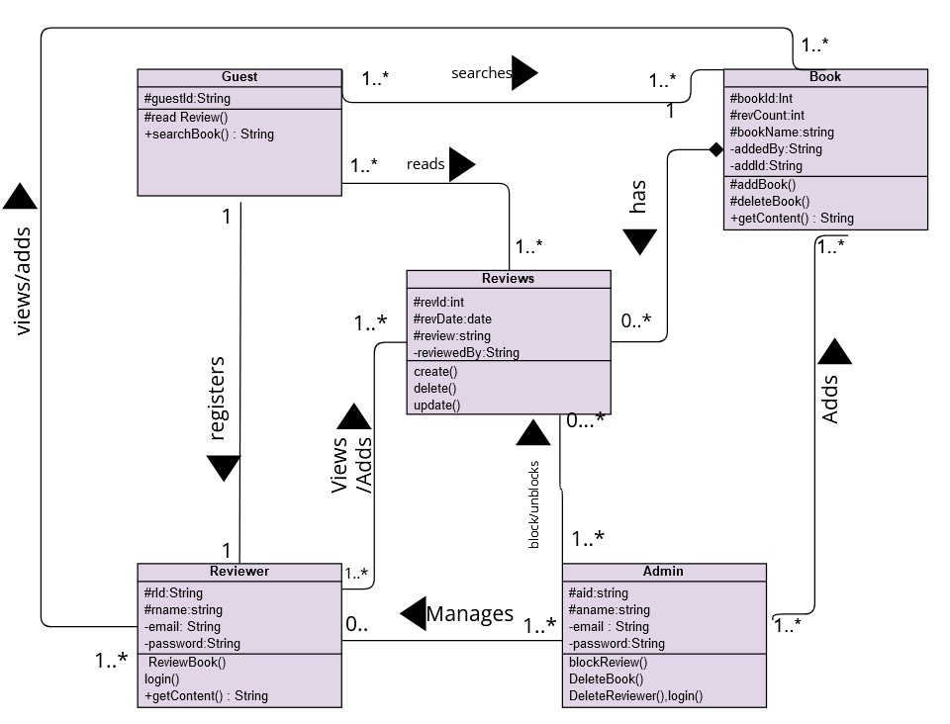

3.3.2Object diagram for User Interaction:-

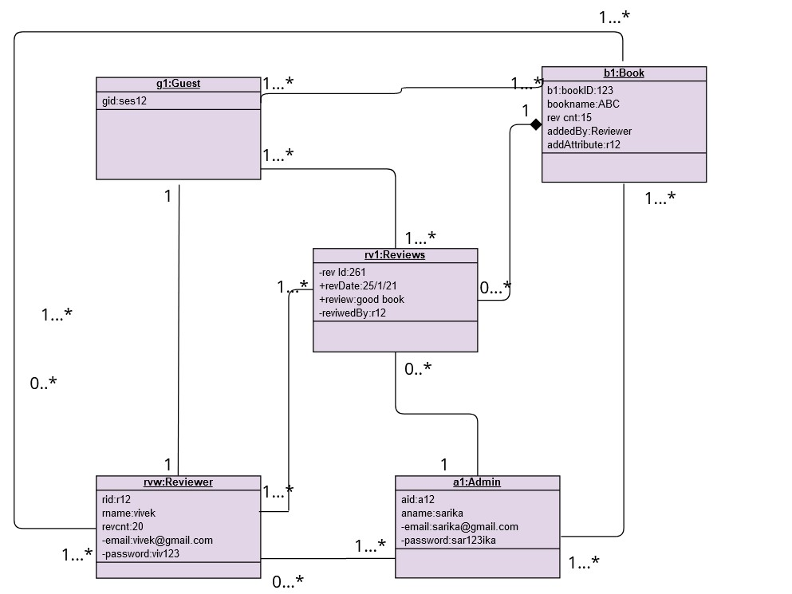

3.3.3 Use Case Diagram for eBook Review system:-

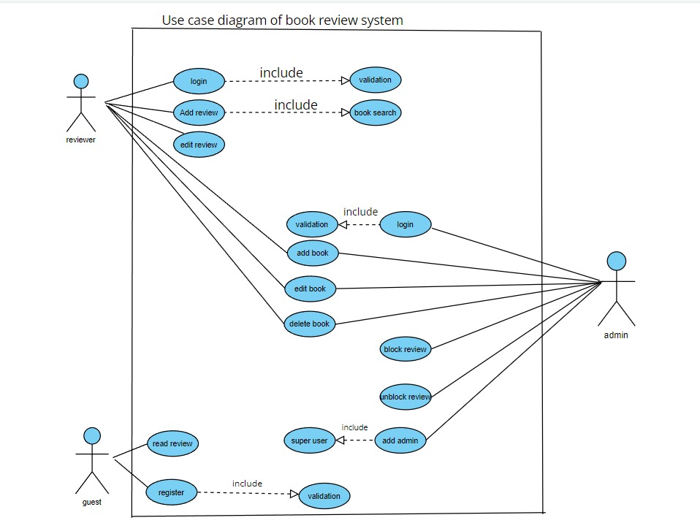

3.3.4 Sequence Diagram for eBook Review system:-

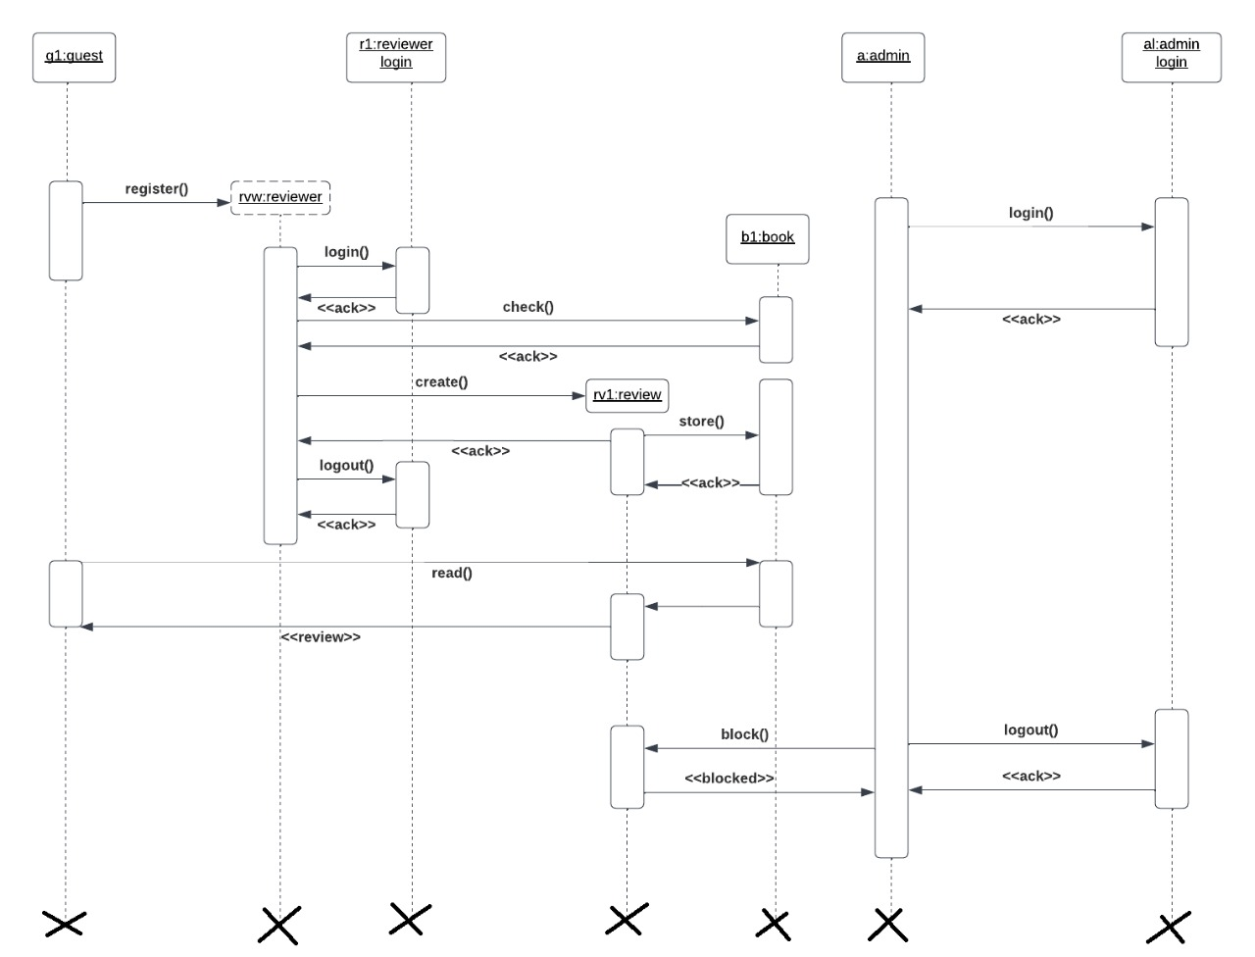

3.3.5) Collaboration Diagram for eBook Review system:-

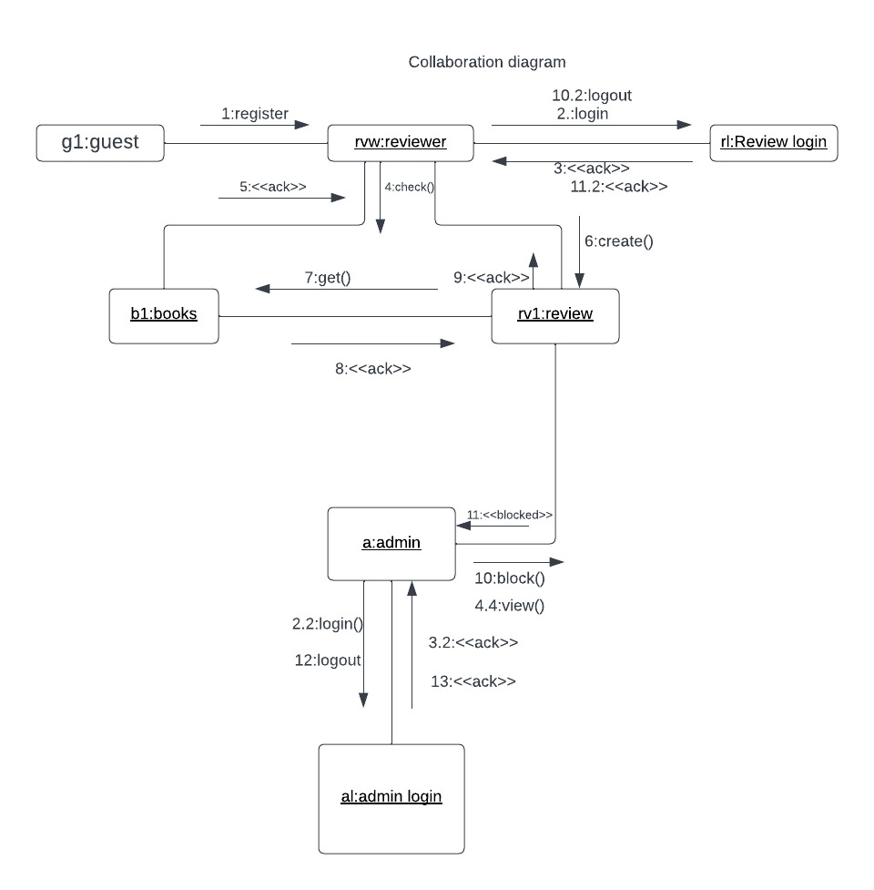

3.3.6 State Diagram for eBook Review system:-

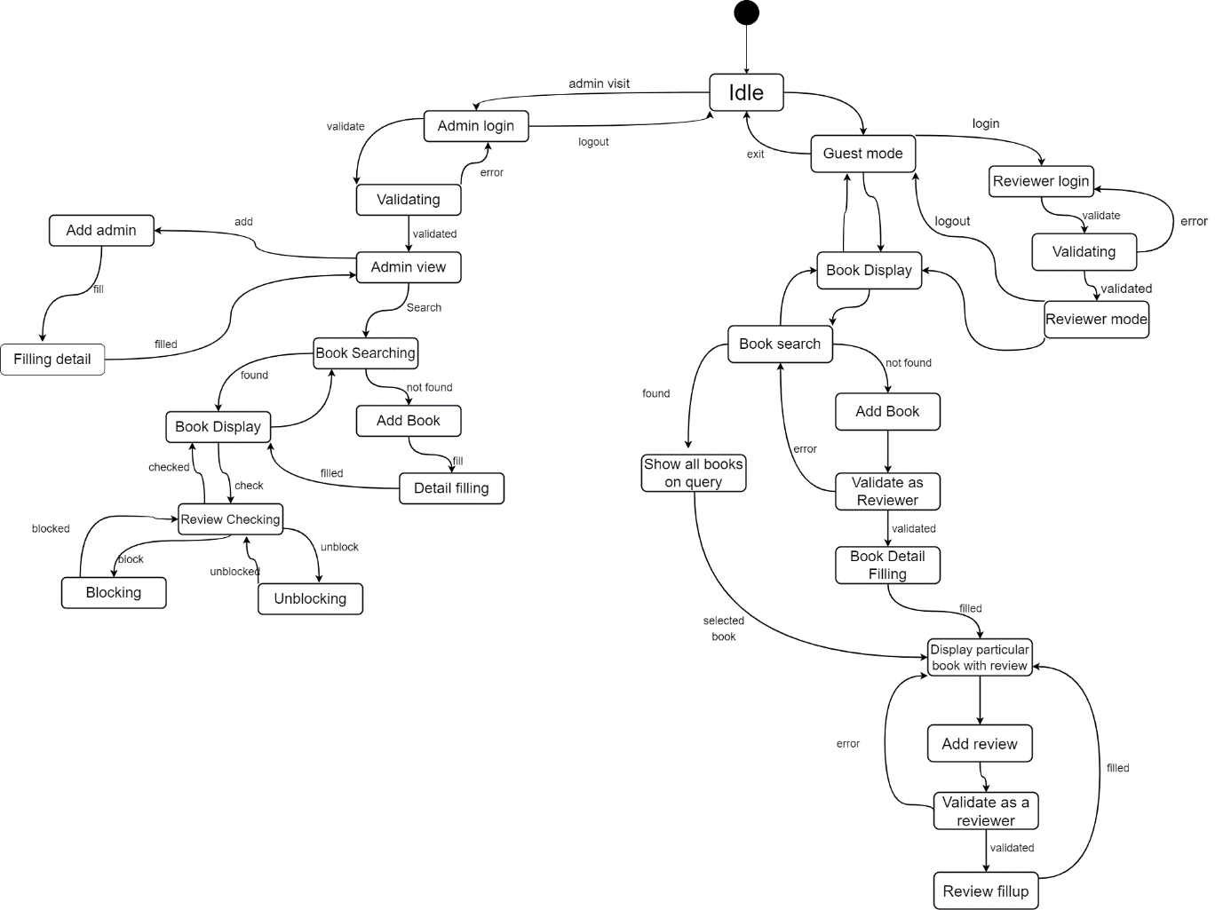

3.3.7) Activity Diagram for eBook Review system

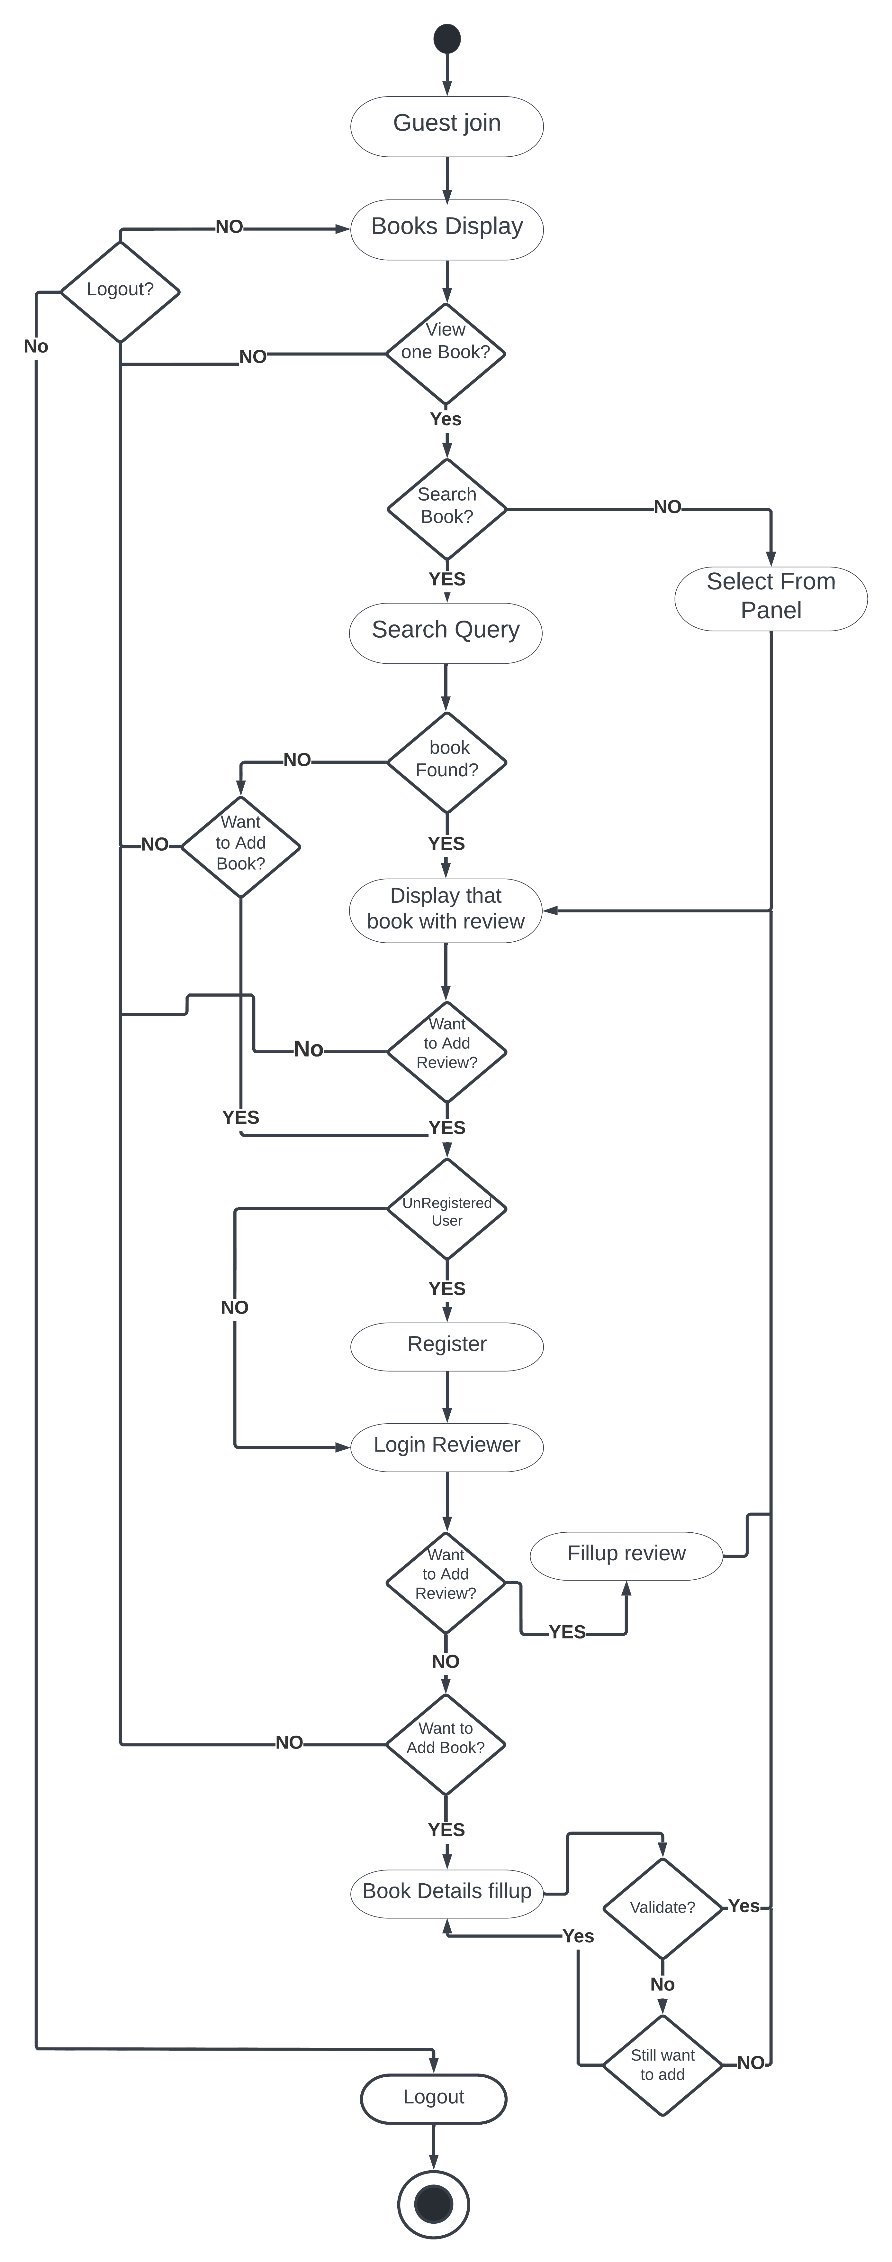

**3.3.8Deployment Diagram for eBook Review** **system:-**

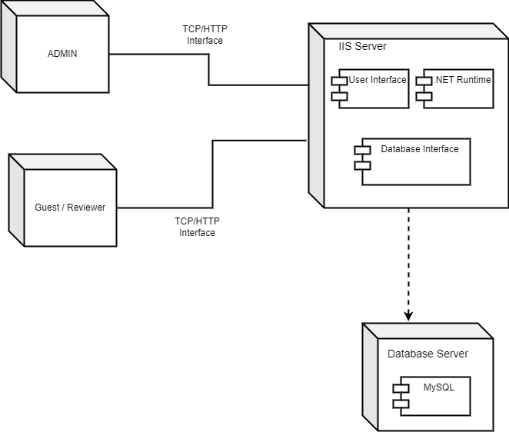

**3.4) Entity Relationship Diagram (ERD)**

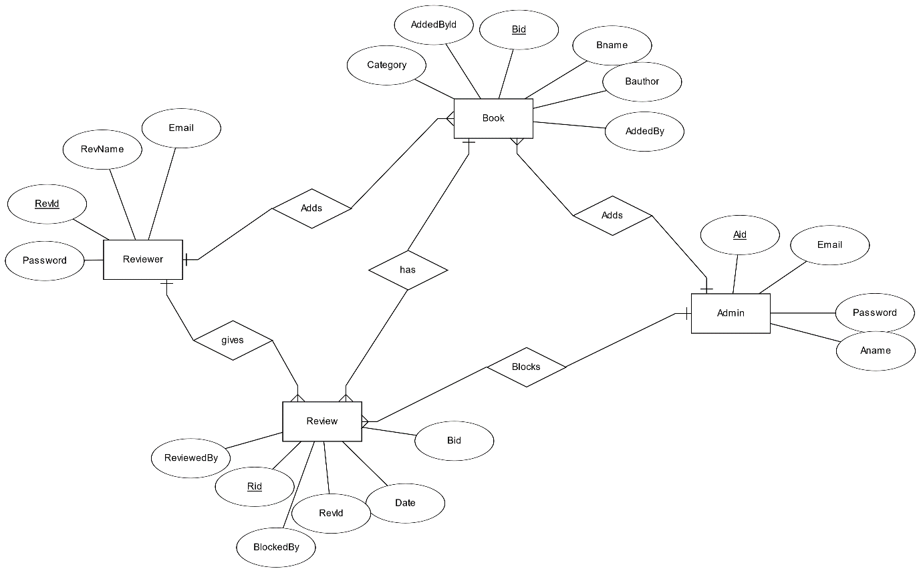

**3.5) Data Dictionary**

**Database :- book_review**

**TableName:- admin**

|  |  |  |  |  |  |
| --- | --- | --- | --- | --- | --- |
| Field | Type | Null | Key | Default | Extra |
| aid | int | NO | PRI | NULL | auto_increment |
| name | varchar(30) | YES |  | NULL |  |
| email | varchar(40) | YES | UNI | NULL |  |
| password | varchar(255) | YES |  | NULL |  |
| profile_pic | varchar(255) | YES |  | NULL |  |

**Database :- book_review**

**TableName:- book**

|  |  |  |  |  |  |
| --- | --- | --- | --- | --- | --- |
| Field | Type | Null | Key | Default | Extra |
| bid | bigint | NO | PRI | NULL | auto_increment |
| book_cover | varchar(255) | YES |  | NULL |  |
| title | varchar(256) | YES |  | NULL |  |
| authors | varchar(512) | YES |  | NULL |  |
| description | varchar(3072) | YES |  | NULL |  |
| year | varchar(4) | YES |  | NULL |  |
| edition | int | YES |  | NULL |  |
| language | varchar(20) | YES |  | NULL |  |
| publisher | varchar(50) | YES |  | NULL |  |
| category | varchar(20) | YES |  | NULL |  |
| aid | int | YES |  | NULL |  |
| ruid | bigint | YES |  | NULL |  |
| page | int | YES |  | NULL |  |

**Database :- book_review**

**TableName:- reviewer**

|  |  |  |  |  |  |
| --- | --- | --- | --- | --- | --- |
| **Field** | **Type** | **Null** | **Key** | **Default** | **Extra** |
| ruid | bigint | NO | PRI | NULL | auto_increment |
| name | varchar(50) | YES |  | NULL |  |
| email | varchar(255) | YES | UNI | NULL |  |
| password | varchar(255) | YES |  | NULL |  |
| profile_pic | varchar(255) | YES |  | NULL |  |
| total_reviews | bigint | YES |  | NULL |  |
| blocked_reviews | tinyint | YES |  | NULL |  |
| is_suspended | tinyint | YES |  | NULL |  |

**Database :- book_review**

**TableName:- reviews**

|  |  |  |  |  |  |
| --- | --- | --- | --- | --- | --- |
| **Field** | **Type** | **Null** | **Key** | **Default** | **Extra** |
| revid | Bigint | NO | PRI | NULL | auto_increment |
| review | varchar(1024) | YES |  | NULL |  |
| review_date | Date | YES |  | NULL |  |
| reviewed_by | Bigint | YES |  | NULL |  |
| review_for | Bigint | YES |  | NULL |  |
| is_blocked | Tinyint | YES |  | NULL |  |
| block_activity | Int | YES |  | NULL |  |
| reviewer_name | varchar(50) | YES |  | NULL |  |

**3.7) Code Design**

**Models**

**Admin.cs**

using System;

using System.Collections.Generic;

using System.Linq;

using System.Web;

using MySql.Data.MySqlClient;

namespace BookReview.Models

{

public class Admin

{

public int aid { get; set; }

public string name { get; set; }

public string email { get; set; }

public string profile_pic { get; set; }

public string password { get; set; }

}

}

**Book.cs**

using System;

using System.Collections.Generic;

using System.Linq;

using System.Web;

namespace BookReview.Models

{

public class Book

{

public long bid { get; set; }

public string book_cover { get; set; }

public string title { get; set; }

public string authors { get; set; }

public string description { get; set; }

public string year { get; set; }

public int edition { get; set; }

public string language { get; set; }

public string publisher { get; set; }

public string category { get; set; }

public int? aid { get; set; }

public long? ruid { get; set; }

public int page { get; set; }

}

}

**Connection.cs**

using System;

using System.Collections.Generic;

using System.Linq;

using System.Web;

using MySql.Data.MySqlClient;

namespace BookReview.Models

{

public class Connection

{

public static MySqlConnection getConnectString()

{

return new MySqlConnection("server=127.0.0.1;uid=Rahul;pwd=rahul@123;database=book_review");

}

}

}

**Reviewer.cs**

using System;

using System.Collections.Generic;

using System.Linq;

using System.Web;

namespace BookReview.Models

{

public class Reviewer

{

public long ruid { get; set; }

public string name { get; set; }

public string email { get; set; }

public string password { get; set; }

public string profile_pic { get; set; }

public long total_reviews { get; set; }

public int blocked_reviews { get; set; }

public int is_suspended { get; set; }

}

}

**Reviews.cs**

using System;

using System.Collections.Generic;

using System.Linq;

using System.Web;

namespace BookReview.Models

{

public class Reviews

{

public long revid { get; set; }

public string review { get; set; }

public string review_date { get; set; }

public long reviewed_by { get; set; }

public long review_for { get; set; }

public int is_blocked { get; set; }

public int block_activity { get; set; }

public string reviewer_name { get; set; }

}

}

**Services**

**AdminService.cs**

#nullable enable

using System;

using System.Collections.Generic;

using System.Linq;

using System.Web;

using MySql.Data.MySqlClient;

using Admin=BookReview.Models.Admin;

using Connection = BookReview.Models.Connection;

using System.Windows.Forms;

namespace BookReview.Services

{

public class AdminService

{

public static Admin? Get(int id)

{

Admin a = new Admin();

try

{

MySqlConnection conn = Connection.getConnectString();

conn.Open();

MySqlCommand cmd = new MySqlCommand($"select * from admin where aid={id}", conn);

MySqlDataReader red = cmd.ExecuteReader();

if (!red.HasRows)

{

red.Close();

conn.Close();

return null;

}

red.Read();

a.aid = Convert.ToInt32(red.GetString("aid"));

a.name = red.GetString("name");

a.email = red.GetString("email");

a.profile_pic = red.GetString("profile_pic");

red.Close();

conn.Close();

}

catch(MySqlException ex) {

return null;

}

return a;

}

public static List<Admin>? Getall()

{

List<Admin> allAdmins = new List<Admin>();

try

{

MySqlConnection conn = Connection.getConnectString();

conn.Open();

string query = "select aid,name,email,profile_pic from admin;";

MySqlDataReader red = (new MySqlCommand(query, conn)).ExecuteReader();

while(red.Read())

{

allAdmins.Add(new Admin() {aid=Convert.ToInt32(red.GetString("aid")),name=red.GetString("name"),email=red.GetString("email"),profile_pic=red.GetString("profile_pic") });

}

red.Close();

conn.Close();

return allAdmins;

}

catch(MySqlException ex)

{ return null; }

}

public static Admin? Update(Admin admin)

{

var chk=Get(admin.aid);

if(chk!=null)

{

try

{

MySqlConnection conn = Connection.getConnectString();

conn.Open();

string query = $"update admin set name=\"{admin.name}\",email=\"{admin.email}\",profile_pic=\"{admin.profile_pic}\" where aid=\"{admin.aid}\" ";

var chkUpdate=(new MySqlCommand(query, conn)).ExecuteNonQuery();

conn.Close();

if (chkUpdate==0)

{

return null;

}

var ad = Get(admin.aid);

return ad;

}

catch(MySqlException ex) { return null; }

}

return null;

}

public static Boolean Add(Admin admin)

{

try

{

MySqlConnection conn = Connection.getConnectString();

conn.Open();

string query = $"insert into admin values(NULL,\"{admin.name}\",\"{admin.email}\",SHA2(\"{admin.password}\",224),\"{admin.profile_pic}\")";

var chkInsert = (new MySqlCommand(query, conn)).ExecuteNonQuery();

conn.Close();

if (chkInsert==0)

{

return false;

}

return true;

}

catch(MySqlException ex)

{ return false; }

}

public static Boolean isEmailRegistered(string email)

{

MySqlConnection conn = Connection.getConnectString();

conn.Open();

string sql = $"select aid from admin where email=\"{email}\"";

object chkEntry = (new MySqlCommand(sql, conn)).ExecuteScalar();

conn.Close();

if (chkEntry == null)

{

return false;

}

return true;

}

}

}

**BookServices.cs**

#nullable enable

using System;

using System.Collections.Generic;

using System.Linq;

using System.Web;

using MySql.Data.MySqlClient;

using BookReview.Models;

using BookReview.Services;

namespace BookReview.Services

{

public class BookServices

{

public static bool isPage(int page)

{

MySqlConnection conn = Connection.getConnectString();

conn.Open();

string query = $"select page from book where page={page}";

object rdr = (new MySqlCommand(query, conn)).ExecuteScalar();

conn.Close();

if (rdr != null)

return true;

return false;

}

public static List<Book>? GetAllInPage(int page)

{

List<Book> books = new List<Book>();

try

{

MySqlConnection conn = Connection.getConnectString();

conn.Open();

string query = $"select bid,book_cover,title from book where page={page}";

MySqlDataReader rdr = (new MySqlCommand(query, conn)).ExecuteReader();

while(rdr.Read())

{

books.Add(new Book() { bid = rdr.GetInt64("bid"), book_cover = rdr.GetString("book_cover"), title = rdr.GetString("title") });

}

rdr.Close();

conn.Close();

return books;

}

catch(MySqlException)

{

return null;

}

}

public static Book? Get(long bid)

{

try

{

MySqlConnection conn = Connection.getConnectString();

conn.Open();

string query = $"select * from book where bid={bid};";

MySqlDataReader red = (new MySqlCommand(query, conn)).ExecuteReader();

if(red.Read())

{

int ordinal;

Book book = new Book();

book.bid = red.GetInt64("bid");

book.book_cover = red.GetString("book_cover");

book.title = red.GetString("title");

book.authors = red.GetString("authors");

book.description = red.GetString("description");

book.year = red.GetString("year");

book.edition = red.GetInt32("edition");

book.language = red.GetString("language");

book.publisher = red.GetString("publisher");

book.category = red.GetString("category");

ordinal = red.GetOrdinal("aid");

if (red.IsDBNull(ordinal))

book.aid = 0;

else

book.aid = red.GetInt32("aid");

ordinal = red.GetOrdinal("ruid");

if (red.IsDBNull(ordinal))

book.ruid = 0;

else

book.ruid = red.GetInt64("ruid");

book.page = red.GetInt32("page");

conn.Close();

return book;

}

conn.Close();

return null;

}

catch(MySqlException ex)

{

return null;

}

}

public static long Add(Book book)

{

try

{

MySqlConnection conn = Connection.getConnectString();

conn.Open();

//LOCK TABLE

(new MySqlCommand("LOCK TABLES book WRITE", conn)).ExecuteNonQuery();

object getPage = (new MySqlCommand("select page from book order by page limit 1;", conn)).ExecuteScalar();

object countPage = (new MySqlCommand($"select count(page) from book where page={getPage};", conn)).ExecuteScalar();

if (Convert.ToInt32(countPage) <= 10)

{

book.page = Convert.ToInt32(getPage);

}

else

{

book.page = Convert.ToInt32(getPage) + 1;

}

string query;

if(book.ruid==0)

{

query = $"insert into book values(NULL,\"default-cover.png\",\"{book.title}\",\"{book.authors}\",\"{book.description}\",\"{book.year}\",{book.edition},\"{book.language}\",\"{book.publisher}\",\"{book.category}\",{book.aid},NULL,{book.page});";

}

else

{

query = $"insert into book values(NULL,\"default-cover.png\",\"{book.title}\",\"{book.authors}\",\"{book.description}\",\"{book.year}\",{book.edition},\"{book.language}\",\"{book.publisher}\",\"{book.category}\",NULL,{book.ruid},{book.page});";

}

var chkInsert = (new MySqlCommand(query, conn)).ExecuteNonQuery();

if(chkInsert==0)

{

return 0;

}

string query2 = "select bid from book order by bid desc limit 1;";

object bidInserted = (new MySqlCommand(query2, conn)).ExecuteScalar();

//UNLOCK TABLE

(new MySqlCommand("UNLOCK TABLES", conn)).ExecuteNonQuery();

conn.Close();

return Convert.ToInt64(bidInserted);

}

catch(MySqlException ex)

{

System.Windows.Forms.MessageBox.Show(ex.ToString());

return 0;

}

}

public static long Update(Book book)

{

try

{

MySqlConnection conn = Connection.getConnectString();

conn.Open();

string query = $"update book set title=\"{book.title}\",authors=\"{book.authors}\",description=\"{book.description}\",year=\"{book.year}\",edition={book.edition},language=\"{book.language}\",publisher=\"{book.publisher}\",category=\"{book.category}\" where bid={book.bid};";

var chkInsert = (new MySqlCommand(query, conn)).ExecuteNonQuery();

conn.Close();

if (chkInsert > 0)

return book.bid;

return 0;

}

catch(MySqlException ex)

{

System.Windows.Forms.MessageBox.Show(ex.ToString());

return 0;

}

}

}

}

**ReviewerService.cs**

#nullable enable

using System;

using System.Collections.Generic;

using System.Linq;

using System.Web;

using MySql.Data.MySqlClient;

using BookReview.Models;

namespace BookReview.Services

{

public class ReviewerService

{

public static Reviewer? Get(long ruid)

{

try

{

MySqlConnection conn = Connection.getConnectString();

conn.Open();

string query = $"select * from reviewer where ruid={ruid};";

MySqlDataReader red = (new MySqlCommand(query, conn)).ExecuteReader();

if (red.HasRows == false)

{

red.Close();

conn.Close();

return null;

}

red.Read();

Reviewer reviewer = new Reviewer();

reviewer.ruid = red.GetInt64("ruid");

reviewer.name = red.GetString("name");

reviewer.email = red.GetString("email");

reviewer.profile_pic = red.GetString("profile_pic");

reviewer.total_reviews = red.GetInt64("total_reviews");

reviewer.blocked_reviews = red.GetInt32("blocked_reviews");

reviewer.is_suspended = red.GetInt32("is_suspended");

reviewer.page = red.GetInt32("page");

red.Close();

conn.Close();

return reviewer;

}

catch (MySqlException ex)

{

return null;

}

}

public static string GetName(long ruid)

{

try

{

MySqlConnection conn = Connection.getConnectString();

conn.Open();

string query = $"select name from reviewer where ruid={ruid};";

object rdr = (new MySqlCommand(query, conn)).ExecuteScalar();

conn.Close();

if (rdr == null)

return "";

return rdr.ToString();

}

catch (MySqlException ex)

{

return "";

}

}

public static Boolean Add(Reviewer reviewer)

{

try

{

MySqlConnection conn = Connection.getConnectString();

conn.Open();

//LOCK reviewer

(new MySqlCommand("Lock Tables reviewer WRITE",conn)).ExecuteNonQuery();

object getPage=(new MySqlCommand("select page from reviewer order by page limit 1;",conn)).ExecuteScalar();

object countPage= (new MySqlCommand($"select count(page) from reviewer where page={getPage};", conn)).ExecuteScalar();

if(Convert.ToInt32(countPage)<=10)

{

reviewer.page = Convert.ToInt32(getPage);

}

else

{

reviewer.page = Convert.ToInt32(getPage)+1;

}

string query = $"insert into reviewer values(NULL,\"{reviewer.name}\",\"{reviewer.email}\",SHA2(\"{reviewer.password}\",224),\"{reviewer.profile_pic}\",{reviewer.total_reviews},{reviewer.blocked_reviews},{reviewer.is_suspended},{reviewer.page});";

var chkInsert = (new MySqlCommand(query, conn)).ExecuteNonQuery();

(new MySqlCommand("UNLOCK TABLES", conn)).ExecuteNonQuery();

//TABLES UNLOCKED

conn.Close();

if (chkInsert == 0)

{

return false;

}

return true;

}

catch(MySqlException ex)

{

return false;

}

}

public static Reviewer? Update(Reviewer reviewer)

{

var chk = Get(reviewer.ruid);

if(chk!=null)

{

try

{

MySqlConnection conn = Connection.getConnectString();

conn.Open();

string query = $"update reviewer set name=\"{reviewer.name}\",email=\"{reviewer.email}\",profile_pic=\"{reviewer.profile_pic}\",total_reviews={reviewer.total_reviews},blocked_reviews={reviewer.blocked_reviews} where ruid={reviewer.ruid};";

var chkUpdate = (new MySqlCommand(query, conn)).ExecuteNonQuery();

conn.Close();

if(chkUpdate==0)

{

return null;

}

var rev = Get(reviewer.ruid);

return rev;

}

catch(MySqlException ex)

{

return null;

}

}

return null;

}

public static bool isEmailRegistered(string email)

{

MySqlConnection conn = Connection.getConnectString();

conn.Open();

string query = $"select ruid from reviewer where email=\"{email}\";";

object red = (new MySqlCommand(query, conn)).ExecuteScalar();

conn.Close();

if (red!=null)

{

return true;

}

return false;

}

public static bool blockCntUpdt(int blkCnt,long ruid)

{

try

{

Boolean is_sus = false;

MySqlConnection conn = Connection.getConnectString();

conn.Open();

string query1 = $"select blocked_reviews from reviewer where ruid={ruid};";

object rdr = (new MySqlCommand(query1, conn)).ExecuteScalar();

int blkTtl = Convert.ToInt32(rdr);

blkTtl += blkCnt;

if (blkTtl >= 3)

is_sus = true;

string query2 = $"update reviewer set is_suspended={is_sus},blocked_reviews={blkTtl} where ruid={ruid}";

var chkUpDate = (new MySqlCommand(query2, conn)).ExecuteNonQuery();

conn.Close();

if (chkUpDate > 0)

return true;

return false;

}

catch(MySqlException ex)

{

System.Windows.Forms.MessageBox.Show(ex.ToString());

return false;

}

}

public static bool totalRevUpdt(int TtlCnt,long ruid)

{

try

{

MySqlConnection conn = Connection.getConnectString();

conn.Open();

string query1 = $"select total_reviews from reviewer where ruid={ruid};";

object rdr = (new MySqlCommand(query1, conn)).ExecuteScalar();

int TtlRev = Convert.ToInt32(rdr);

TtlRev += TtlCnt;

string query2 = $"update reviewer set total_reviews={TtlRev} where ruid={ruid};";

var chkUpDate = (new MySqlCommand(query2, conn)).ExecuteNonQuery();

conn.Close();

if (chkUpDate > 0)

return true;

return false;

}

catch (MySqlException ex)

{

System.Windows.Forms.MessageBox.Show(ex.ToString());

return false;

}

}

}

}

**ReviewsService.cs**

#nullable enable

using System;

using System.Collections.Generic;

using System.Linq;

using System.Web;

using BookReview.Models;

using MySql.Data.MySqlClient;

namespace BookReview.Services

{

public class ReviewsService

{

public static List<Reviews>? GetByBook(long bid)

{

try

{

List<Reviews> bookReviews = new List<Reviews>();

MySqlConnection conn = Connection.getConnectString();

conn.Open();

string query = $"select * from reviews where review_for={bid};";

MySqlDataReader rdr = (new MySqlCommand(query, conn)).ExecuteReader();

while (rdr.Read())

{

bookReviews.Add(new Reviews() { revid = rdr.GetInt64("revid"), review = rdr.GetString("review"), review_date = rdr.GetString("review_date").Split(' ')[0], review_for = rdr.GetInt64("review_for"), is_blocked = rdr.GetInt32("is_blocked"), reviewer_name = rdr.GetString("reviewer_name"),reviewed_by=rdr.GetInt64("reviewed_by") });

}

rdr.Close();

conn.Close();

return bookReviews;

}

catch(MySqlException ex)

{

return null;

}

}

public static Reviews? GetById(long revid)

{

try

{

MySqlConnection conn = Connection.getConnectString();

conn.Open();

string query = $"select * from reviews where revid={revid}";

MySqlDataReader rdr = (new MySqlCommand(query, conn)).ExecuteReader();

if (rdr.Read())

{

Reviews reviw = new Reviews();

reviw.revid = rdr.GetInt64("revid");

reviw.review = rdr.GetString("review");

reviw.review_date = rdr.GetString("review_date").Split(' ')[0];

reviw.reviewed_by = rdr.GetInt64("reviewed_by");

reviw.review_for = rdr.GetInt64("review_for");

reviw.is_blocked = rdr.GetInt16("is_blocked");

reviw.reviewer_name = rdr.GetString("reviewer_name");

var ordinal = rdr.GetOrdinal("block_activity");

if (rdr.IsDBNull(ordinal))

reviw.block_activity = 0;

else

reviw.block_activity = rdr.GetInt32("block_activity");

rdr.Close();

conn.Close();

return reviw;

}

else

return null;

}

catch (MySqlException ex)

{

return null;

}

}

public static bool Add(Reviews revew )

{

try

{

MySqlConnection conn = Connection.getConnectString();

conn.Open();

string query = $"insert into reviews values(NULL,\"{revew.review}\",\"{revew.review_date}\",\"{revew.reviewed_by}\",{revew.review_for},{revew.is_blocked},{revew.block_activity},\"{revew.reviewer_name}\");";

var chkInsert = (new MySqlCommand(query, conn)).ExecuteNonQuery();

conn.Close();

ReviewerService.totalRevUpdt(1, revew.reviewed_by);

if (chkInsert > 0)

return true;

return false;

}

catch(MySqlException ex)

{

return false;

}

}

public static bool Update(Reviews reviw)

{

try

{

var chkId = GetById(reviw.revid);

if (chkId != null)

{

MySqlConnection conn = Connection.getConnectString();

conn.Open();

string query = $"update reviews set review=\"{reviw.review}\",review_date=\"{reviw.review_date}\" where revid={reviw.revid};";

var chkUpdate = (new MySqlCommand(query, conn)).ExecuteNonQuery();

conn.Close();

if (chkUpdate > 0)

return true;

}

return false;

}

catch(MySqlException ex)

{

return false;

}

}

public static bool toggleBlock(long revid,int aid)

{

try

{

MySqlConnection conn = Connection.getConnectString();

conn.Open();

string query2 = $"select is_blocked,reviewed_by from reviews where revid={revid};";

MySqlDataReader rdr = (new MySqlCommand(query2, conn)).ExecuteReader();

rdr.Read();

Boolean BLK_FLG = !rdr.GetBoolean("is_blocked");

long reviewed_by= rdr.GetInt64("reviewed_by");

rdr.Close();

string query = $"update reviews set is_blocked={BLK_FLG},block_activity={aid} where revid={revid};";

var chkBlk=(new MySqlCommand(query, conn)).ExecuteNonQuery();

conn.Close();

if (BLK_FLG==false)

ReviewerService.blockCntUpdt(-1,reviewed_by);

else

ReviewerService.blockCntUpdt(1, reviewed_by);

if (chkBlk > 0)

return true;

return false;

}

catch(MySqlException ex)

{

System.Windows.Forms.MessageBox.Show(ex.ToString());

return false;

}

}

public static bool Delete(long revid)

{

try

{

MySqlConnection conn = Connection.getConnectString();

conn.Open();

string query = $"delete from reviews where revid={revid};";

var chkDlt = (new MySqlCommand(query, conn)).ExecuteNonQuery();

conn.Close();

ReviewerService.totalRevUpdt(-1, revid);

if (chkDlt > 0)

return true;

return false;

}

catch(MySqlException ex)

{

return false;

}

}

}

}

**3.8) Screens**

**User Side Screens**

**1)Home Page**





**2) Add Book Page(NOT LOGGEDIN)-**



**3)Login Page-**

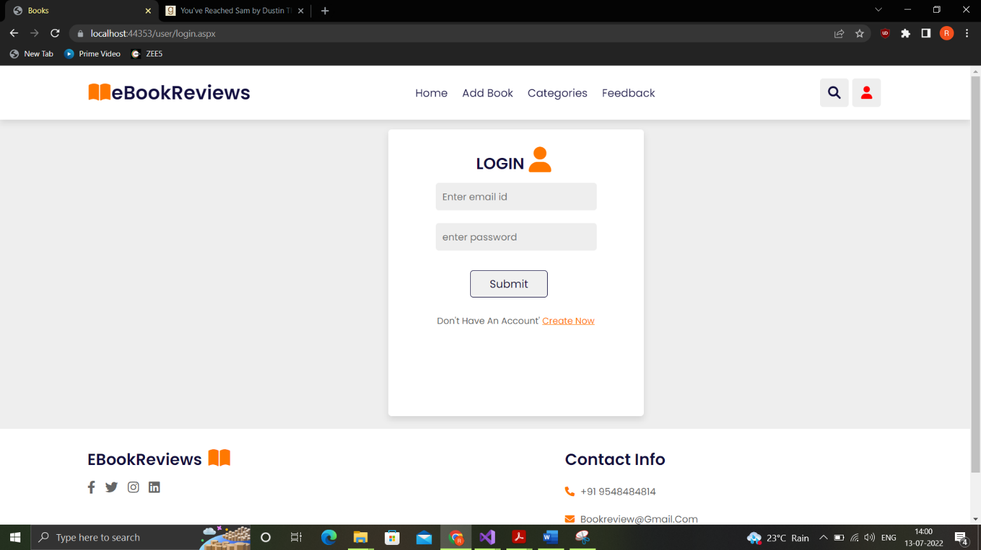

**3)Register Page-**

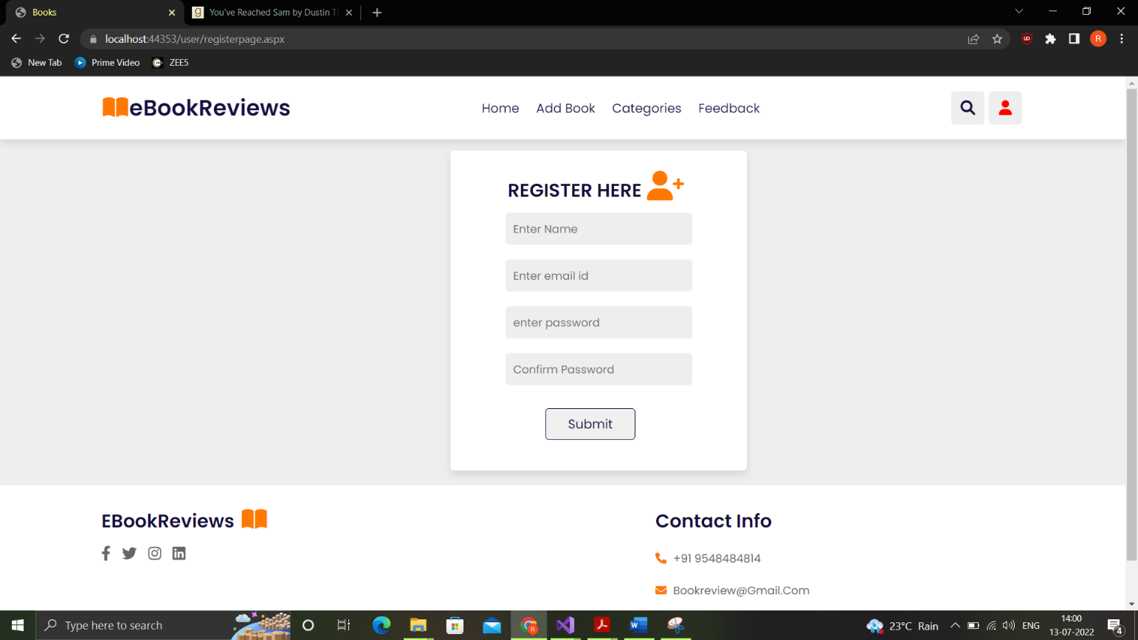

**4)Add Book Page After Login-**

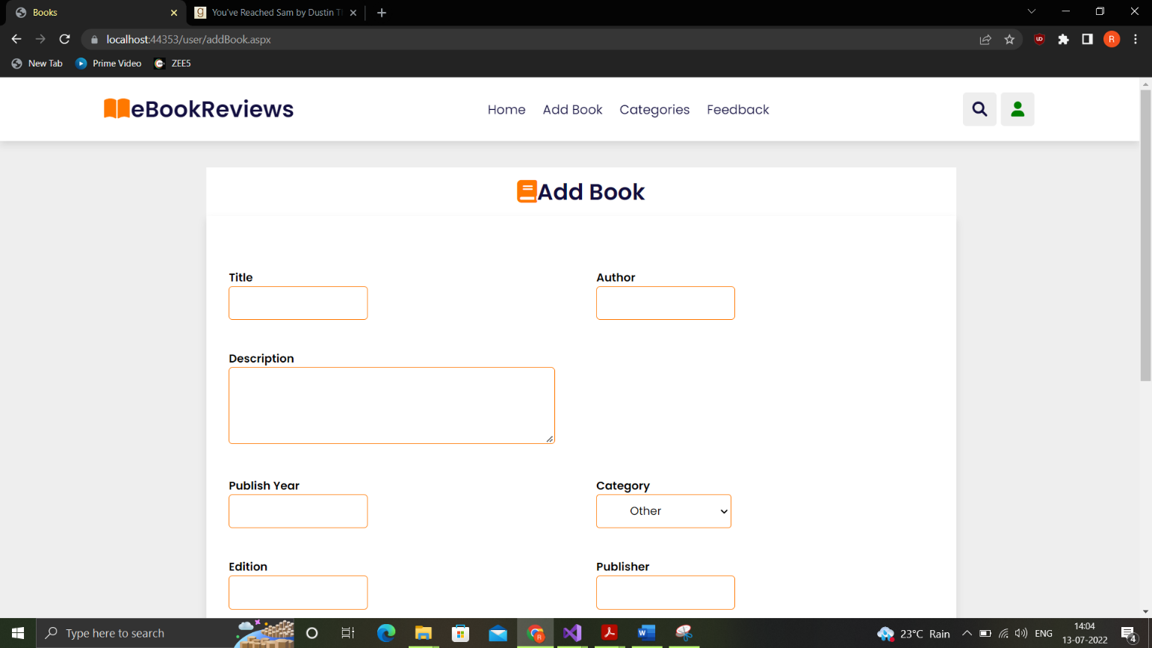

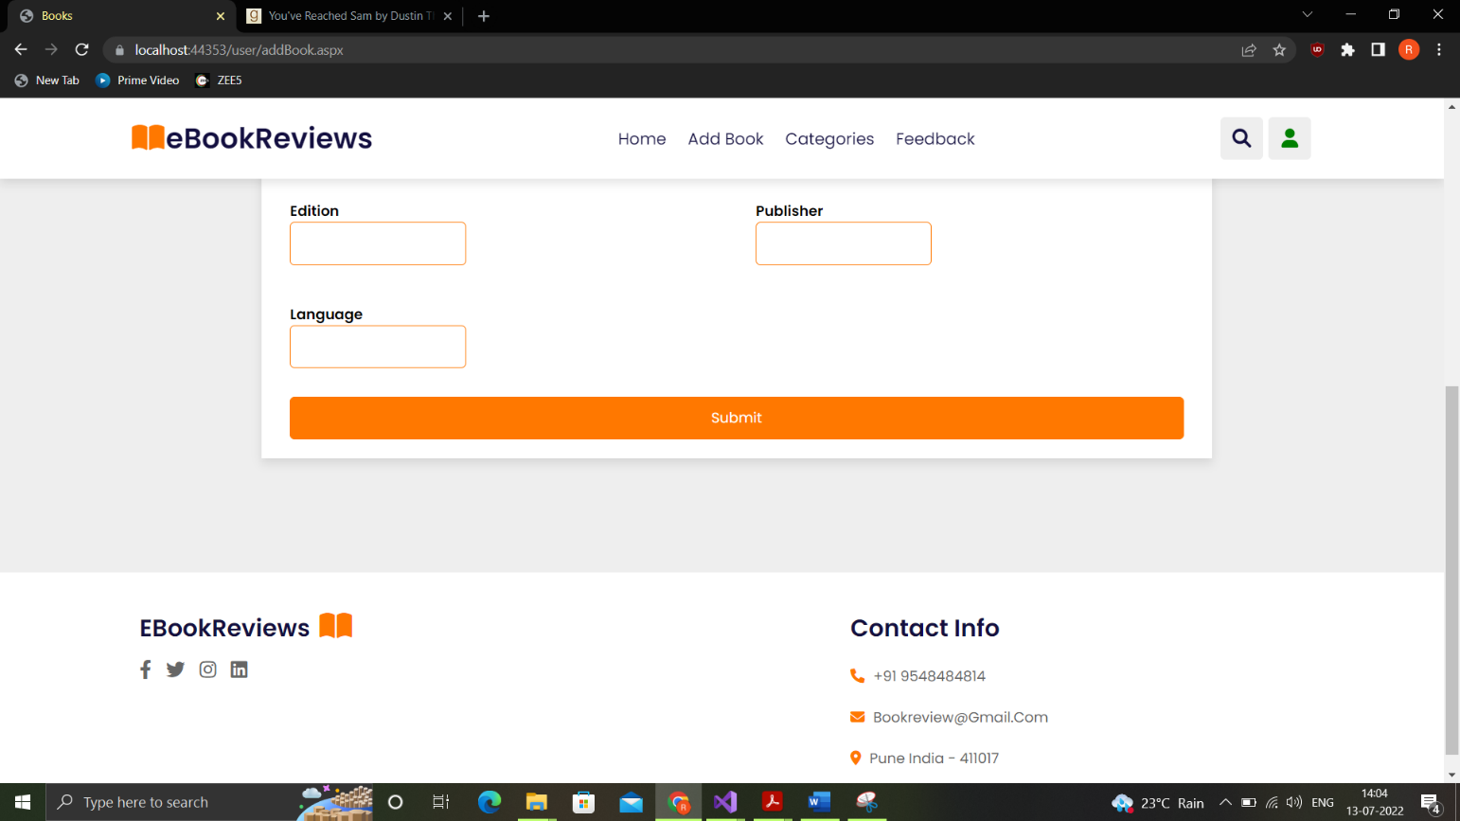

**5)Categories Page-**



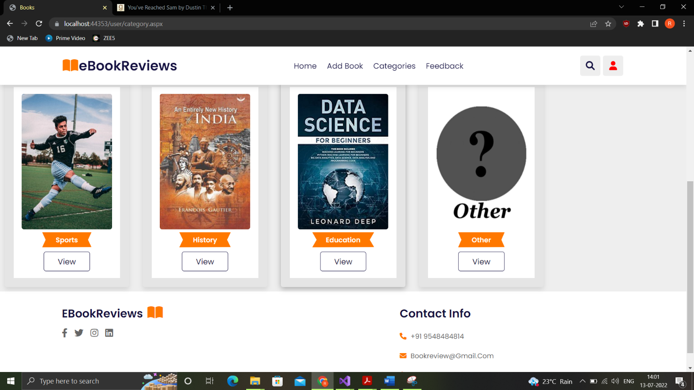

**6)After Clicking on View Book-**

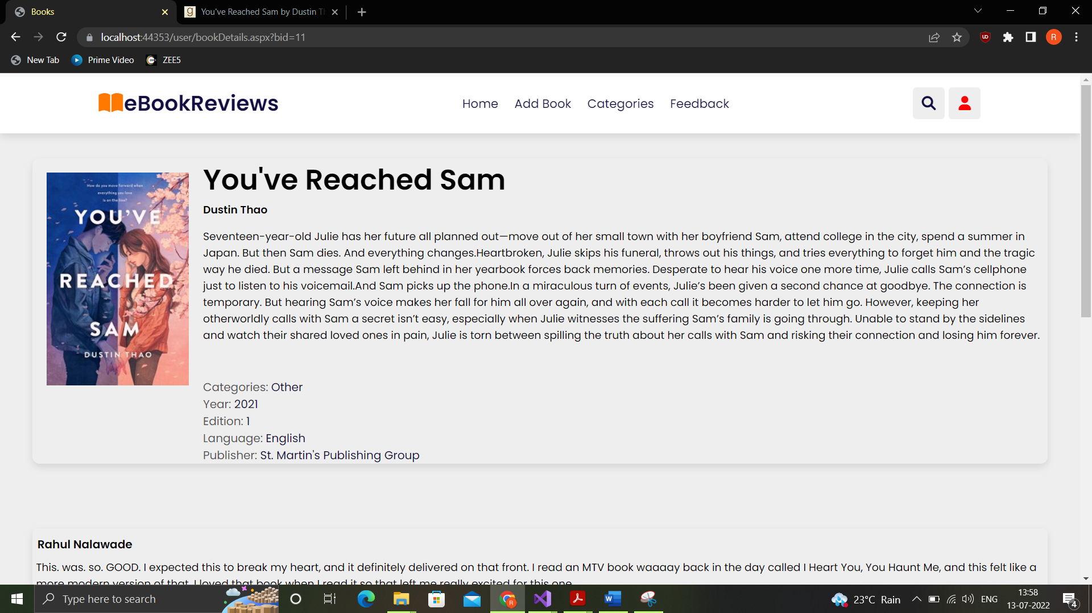



**7)Edit Review Page-**

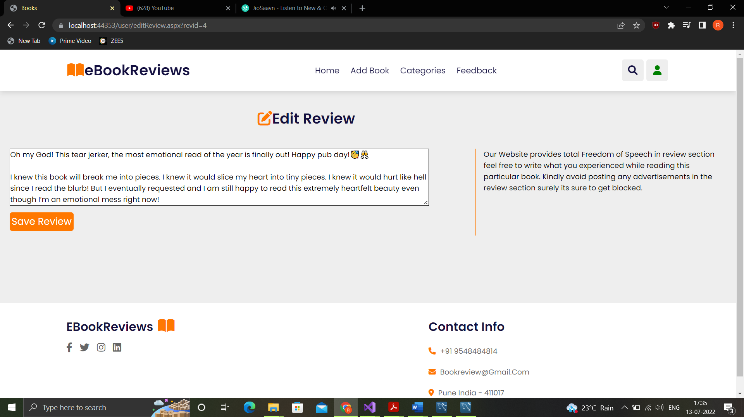

**Admin Side Screens-**

**9) Admin Login Page-**

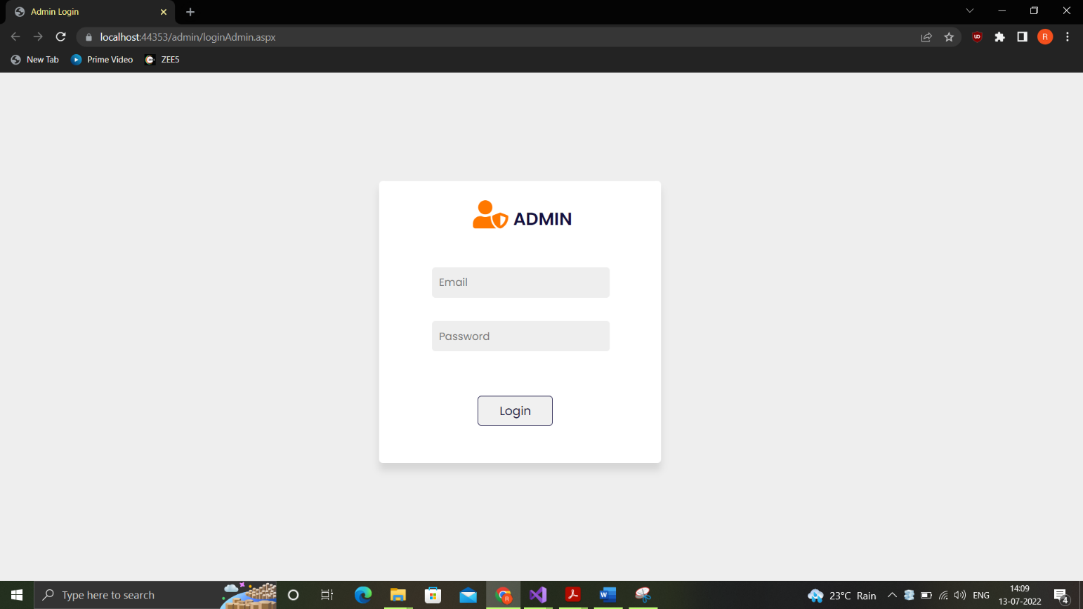

**9) Admin Home Page-**

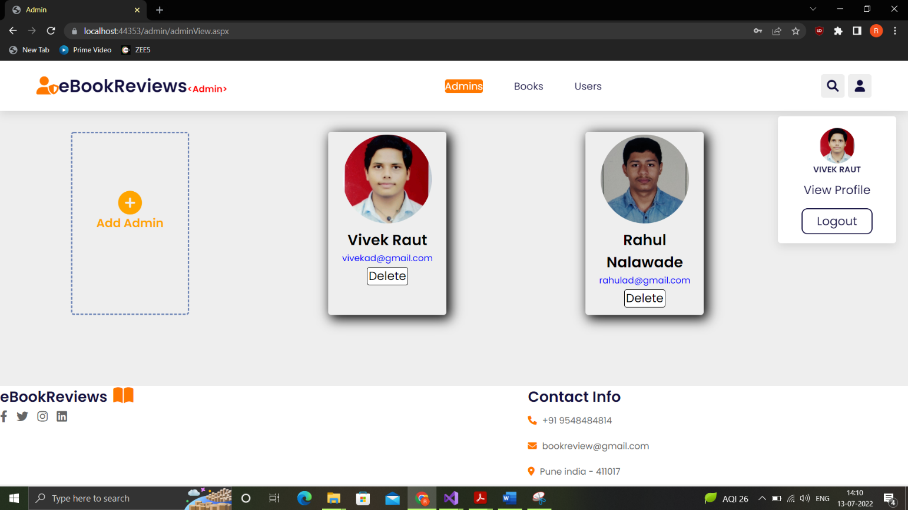

**9) View Profile Page-**

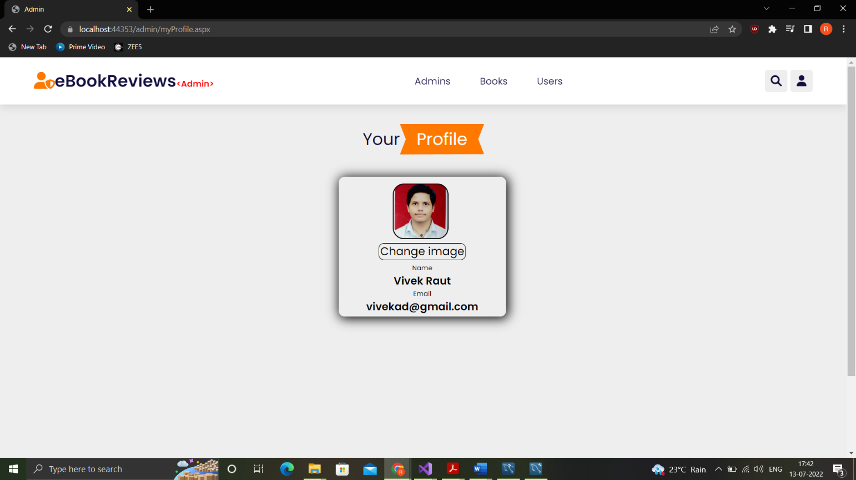

**10) Add Admin Page-**

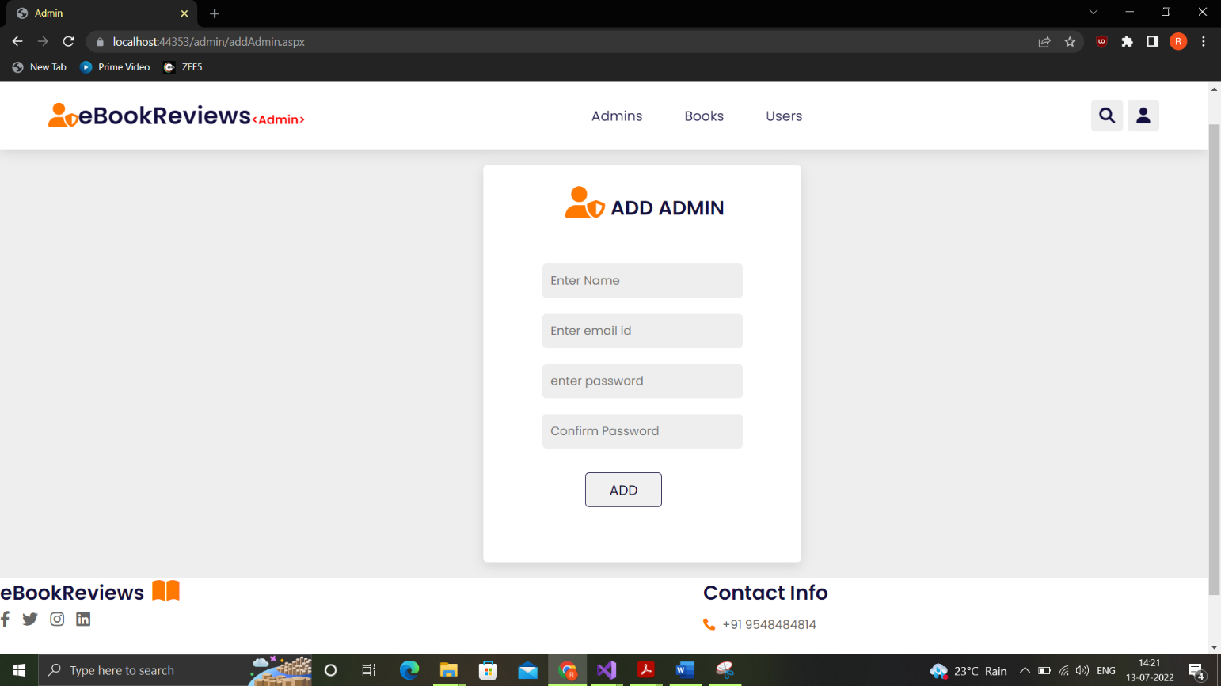

**10) Admin Books Page-**



**10) After clicking on View (Admin side)-**





**11) After Blocking a Review (Admin side)-**



**12) Editing Book Details (Admin side)-**

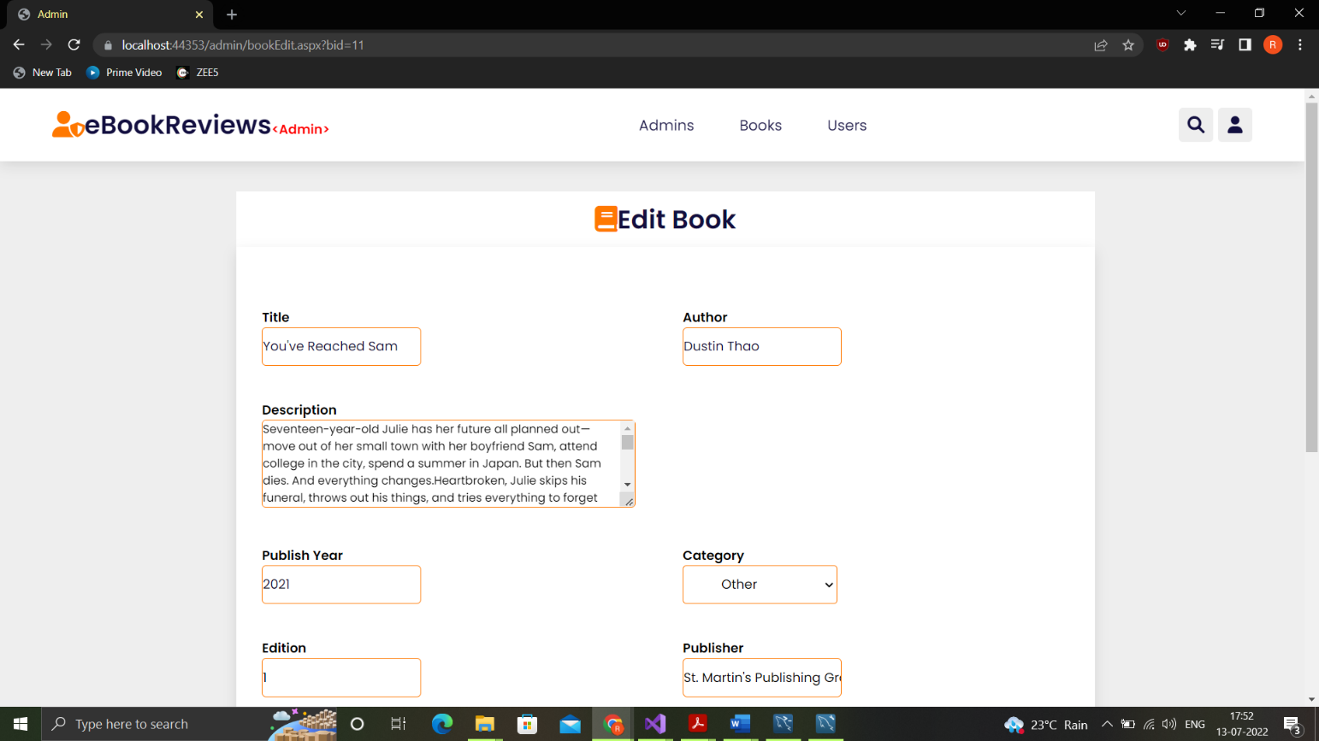

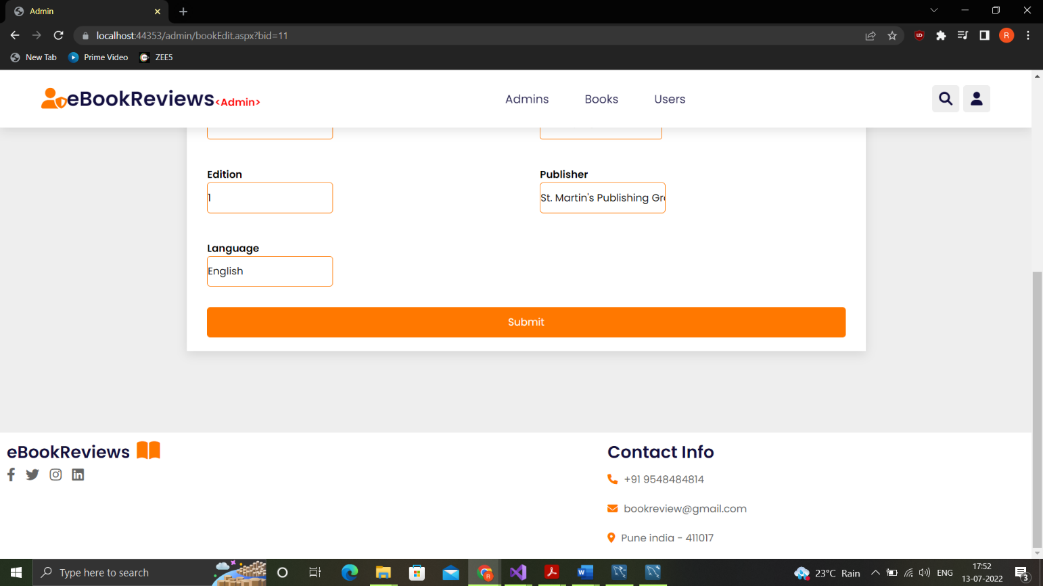

**13) User Review History**

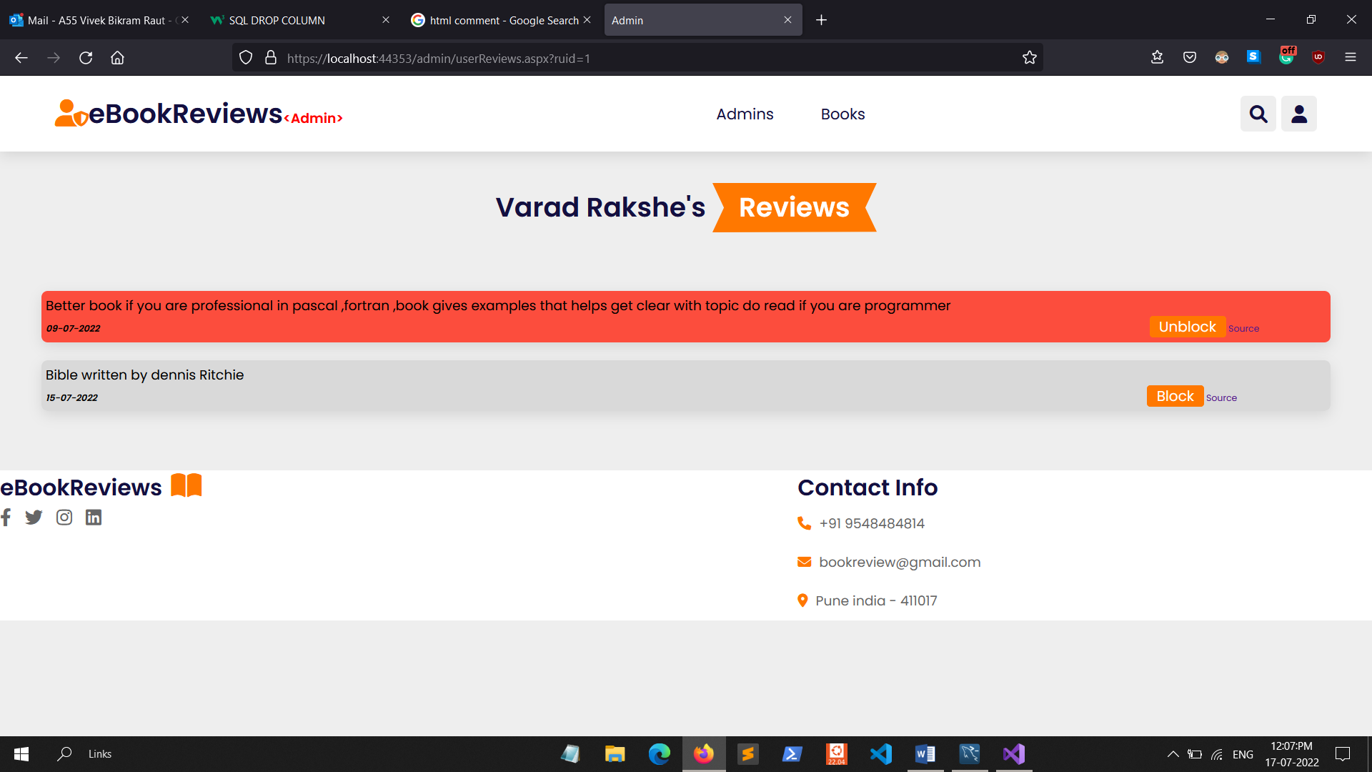**14)User Add Book History**

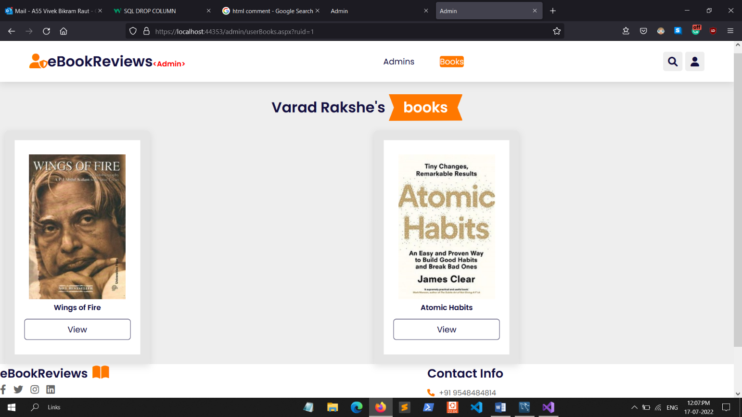

**Conclusion**

This project gave me an opportunity to understand the basic flow of Book Review System as per the expectation of the client and the challenges one faces during the course of developing and implementing the project successfully. We had the unique opportunity to work not just of a Book Review System but a Reporting solution which will help the client to reduce manual review input.

During the course of this internship I got a unique opportunity to interact with the team members at various locations in the world.

It gives us immense pleasure and satisfaction to do a project in a field, I have always been interested in and which allowed me to use my desire to learn new technology and use my technical skills in an excellent way to give a result which was required, which has gone beyond my own expectations.

**BIBLIOGRAPHY**

**Websites**

* <https://docs.microsoft.com/en-us/aspnet/core/?view=aspnetcore-6.0>
* <https://www.c-sharpcorner.com/>

**Database**

* <https://dev.mysql.com/doc/connector-net/en/connector-net-ref.html>
* <https://dev.mysql.com/doc/dev/connector-net/6.10/html/connector-net-reference.htm>

**HTML UI**

* <https://www.youtube.com/watch?v=lCCN_lkl3Xw&t=2187s>